1. ROI (Return on Investment) by Device Type
This query calculates how much money you spent versus how much revenue you generated for each device (Mobile, Tablet, Desktop), giving you the actual Return on Investment (ROI).

QUERY-;
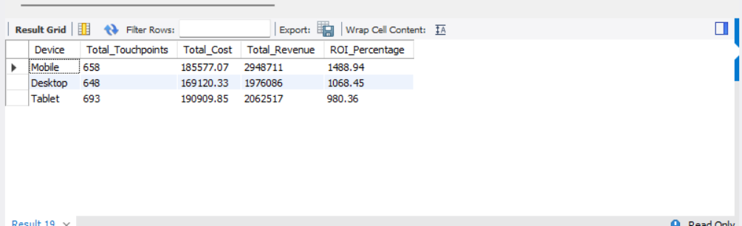
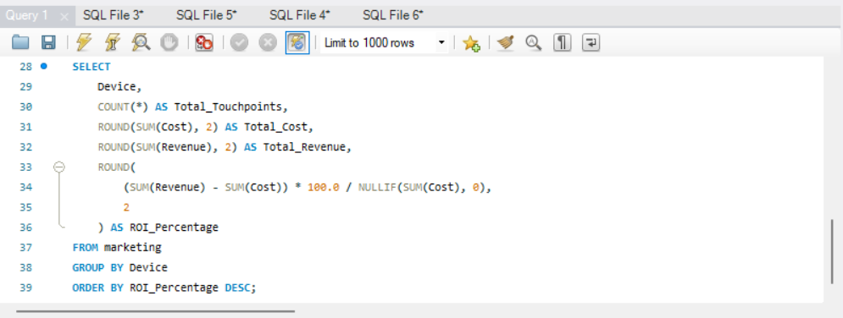

SOLUTION-;

